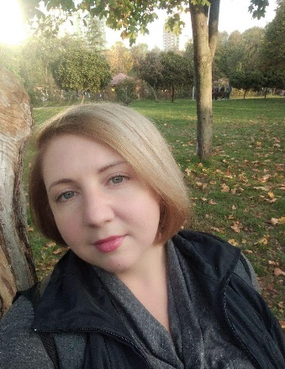
YULIIA KRAVCHENKO (ЮЛИЯ КРАВЧЕНКО)

Date of birth: 15.01.1983
Telefone. 53750551
Viber, Telegram, WhatsApp +380676828776
E-mail: y.kravchenko.psy@gmail.com
Facebook https://www.facebook.com/profile.php?id=100001225437387

Working Experience
2020-…. «Psychological Centre of Eduard Pomytkin»
Position: psychologist-consultant
2019-…. «National aviation university»
Aviation psychology department
Position: psychologist, teacher, curator of student’s groups
2014-2020 Children's camp «Robinzonia»
Position: psychologist, leader of the camp counselors team
2013– 2019 Aerospace Lyceum of National aviation university
Position: psychologist, teacher.
Professional Skills:
Individual and group psychological counseling.
Individual and group psychological correction.
Teaching and learning for different age groups, including adult education, work with personnel.
Organizational and manager’s skills.
Skills to plan and successfully implement company objectives.
The main directions of psychological activity:
parent-child relations, personality development, goal-setting, coping difficult life situations.
Образование
1999-2004 National Pedagogical University named after M.P. Drahomanov
Speciality: history teacher
2011- 2014 University of Education Management" of the National Academy of Pedagogical Sciences of Ukraine
Speciality: psychologist, psychology teacher of institution of higher education.
2020-…. National aviation university
Aviation psychology department
Applicant for a scientific degree PhD
Additional education:
2010 «University of Economics and Law «CROCK»
Training course «HR Director»
2019 All-Ukrainian public organization «Sviti»
Training course «Training for trainers with elements of coaching»
2020 Institute of Applied Social Technologies (St. Petersburg)
Online training course «Psychological correction of psychosomatic diseases»

Personal qualities:
Sociability, ability to work in a team and independently, organization, responsibility, purposefulness, high level of learning, positive life outlook.

Additional Information:
October 2021 - February 2022 I worked in Kindergarten and Elementary School as a psychologist – carried out group classes with children, individual work with children and consultations for parents

From 2013 I have conducted a huge number of art therapy classes for children from 3 years old and teenagers, as well as consultations for parents, thanks to which parents found a common language with their children.

Also, my scientific work is devoted to effective parenting and I would love to work with children and their parents.

I have extensive experience working with teenagers: building a life path, understanding themselves and their place in the world, establishing communication with parents, as well as consultation for teenagers parents.

I have a certificate of a trainer, as well as author's trainings for teenagers and experience in their conduction.

For the past two years, part of my job has been teaching at the Department of Psychology.
I taught the following disciplines:
Theory and practice of psychotraining.
Teambuilding.
Coaching.
Emotional intelligence.
General Psychology workshop.

